**Probability and Statistics – IT2120**

**Lab Sheet 09**

**IT24104128**

**Palapagama T.H.P**

1. i)

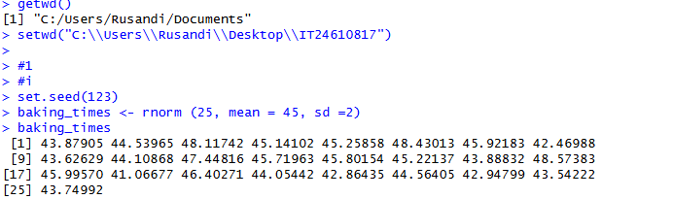

ii)

